**OEE351-RENEWABLE ENERGY SYSTEM**

**UNIT II - SOLAR ENERGY**

**1. Discuss the methods of measuring solar radiation and their importance in solar energy** **applications.**

**Methods of Measuring Solar Radiation:**

1. **Pyranometer**
   * **Definition**: A pyranometer is an instrument used to measure the global solar radiation received on a horizontal surface.
   * **Working Principle**: It consists of a thermopile sensor that absorbs radiation and converts it into a temperature difference. This difference generates a voltage, which is proportional to the intensity of the solar radiation.
   * **Importance**: It is widely used in solar energy applications to assess the potential of solar power generation.

**Types of Pyranometer:**

1. **Eppley Pyranometer**
   * **Description**: A highly accurate, widely used pyranometer that measures the total solar radiation received on a horizontal surface.
   * **Working Principle**: Uses a thermopile sensor to measure the temperature difference caused by the absorbed solar radiation, which generates a proportional electrical signal.
   * **Applications**: Primarily used in meteorological stations and solar energy studies to monitor global solar radiation.
2. **Yellot Solarimeter(Photovoltaic cell Pyranometer)**
   * **Description**: A portable, lightweight pyranometer designed for easy field measurements of solar radiation.
   * **Working Principle**: Contains a thermopile sensor, and it measures radiation by detecting the heating effect of solar energy on the sensor.
   * **Applications**: Commonly used for practical solar radiation measurements in various outdoor conditions and for small-scale solar projects.
3. **Mollo-Groczynski Pyranometer**
   * **Description**: Known for its low-cost and simple design, this pyranometer is used for solar radiation measurements, particularly in educational setups.
   * **Working Principle**: It utilizes a thermocouple sensor that produces a voltage based on the temperature difference between the radiation-absorbing surface and the surrounding environment.
   * **Applications**: Useful for educational purposes, research projects, and low-budget solar radiation monitoring.
4. **Bimetallic Pyranometer**
   * **Description**: A type of pyranometer that uses two different metals to create a bimetallic strip, which bends with temperature changes caused by solar radiation.
   * **Working Principle**: The bimetallic strip bends when heated by absorbed radiation, and this mechanical movement is measured to determine the intensity of solar radiation.
   * **Applications**: Typically used in less demanding applications where precise accuracy is not critical.
5. **Yanishevsky Pyranometer**
   * **Description**: A pyranometer that uses a different type of thermoelectric sensor to measure solar radiation.
   * **Working Principle**: It operates based on the principle of thermoelectricity, where the temperature differential caused by radiation is converted into an electrical signal.
   * **Applications**: Mainly used in scientific studies and research where higher precision and sensitivity are required.
6. **Dimhirn-Sauberer Pyranometer**
   * **Description**: This pyranometer is known for its durability and use in harsh weather conditions.
   * **Working Principle**: Similar to other pyranometers, it measures solar radiation via a thermopile sensor, with enhanced materials designed to withstand extreme environmental conditions.
   * **Applications**: Suitable for use in extreme climates and long-term solar radiation monitoring stations.
7. **Pyrheliometer**
   * **Definition**: A pyrheliometer measures direct solar radiation received from the sun’s disk.
   * **Working Principle**: It uses a thermopile sensor placed in a collimated beam of sunlight. The instrument measures only the radiation directly coming from the sun.
   * **Importance**: Useful for understanding the intensity of direct sunlight and for studying solar energy systems that depend on direct radiation.

**Types of Pyrheliometer:**

1. **Angstrom Pyrheliometer**
   * **Description**: A pyrheliometer designed by Angstrom that measures direct solar radiation with high precision.
   * **Working Principle**: It uses a thermopile sensor and a collimator tube to focus sunlight onto the sensor. It provides accurate readings for direct solar radiation.
   * **Applications**: Commonly used in solar energy research, particularly in studying the direct radiation received from the sun.
2. **Abbot Silver Disc Pyrheliometer**
   * **Description**: A pyrheliometer that uses a silver disc as the radiative surface for detecting direct solar radiation.
   * **Working Principle**: The silver disc absorbs direct sunlight, and the temperature increase is measured using a thermopile. The temperature difference correlates with the intensity of solar radiation.
   * **Applications**: Typically used in meteorological research and solar radiation measurement for high-accuracy data collection.
3. **Eppley Pyrheliometer**
   * **Description**: Eppley also manufactures pyrheliometers specifically designed to measure the direct component of solar radiation.
   * **Working Principle**: Eppley pyrheliometers use a thermopile sensor and a sun tracker to continuously measure the solar radiation coming directly from the sun’s disk.
   * **Applications**: Commonly used in global radiation measurement systems, weather stations, and solar energy research.

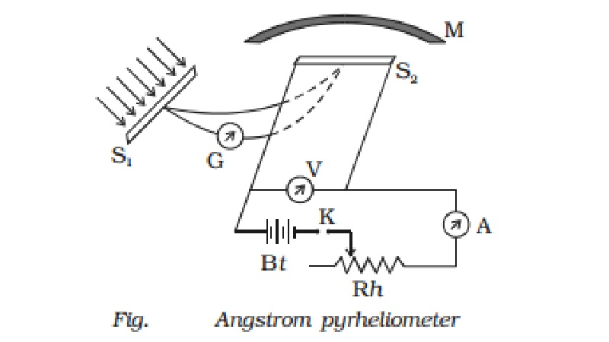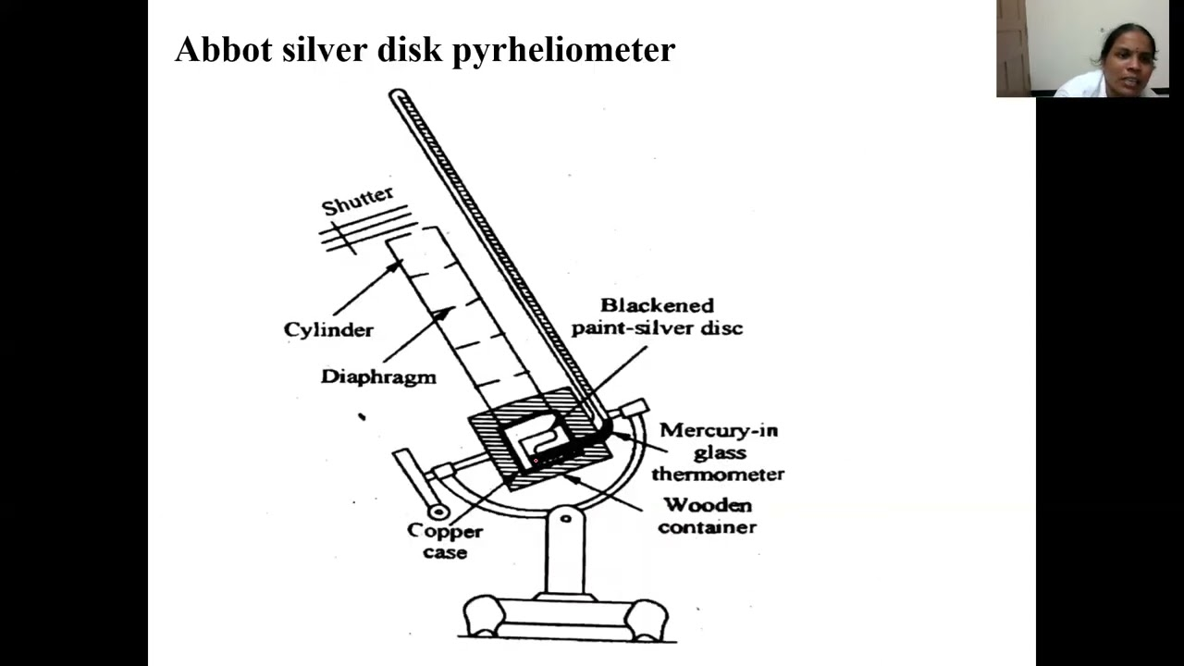

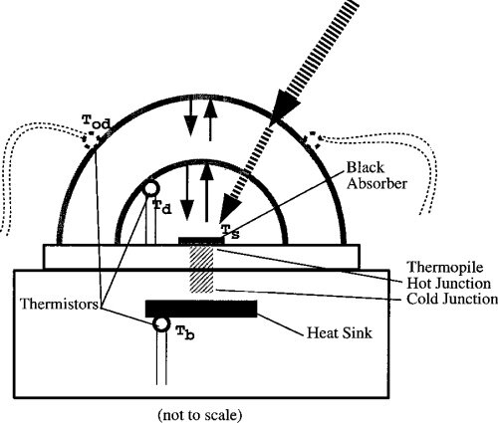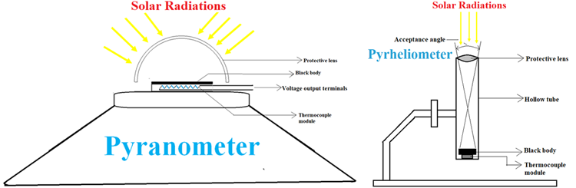

**2. Compare and contrast the different types of concentrating collectors and their efficiencies.**

Concentrating solar collectors use mirrors or lenses to focus a large area of sunlight onto a smaller receiver. This increases the temperature of the fluid in the receiver, making it suitable for medium to high-temperature applications like power generation.

**1. Parabolic Dish Collector**

**Definition:** A parabolic dish collector consists of a dish-shaped mirror surface that reflects and concentrates solar radiation onto a single focal point where a receiver or engine is located.

**Working Principle:** The parabolic shape focuses all incoming parallel rays of sunlight onto a small receiver located at the focal point of the dish. The receiver absorbs this concentrated energy and either heats a fluid or powers a Stirling engine to generate electricity.

**Key Points:**

1. The system requires **dual-axis tracking**, meaning it follows the sun’s path both horizontally and vertically for maximum efficiency throughout the day.
2. It produces **very high temperatures**, often exceeding 500°C, making it ideal for applications like electricity generation and industrial heating.
3. Efficiency is typically **higher than other collectors**, around 40–45%, because of precise focusing and minimal heat losses.
4. It is best suited for **standalone applications** and **remote locations** where small, high-efficiency power systems are needed.

**2. Parabolic Trough Collector**

**Definition:** A parabolic trough collector is a linear concentrating system where a parabolic-shaped reflector focuses sunlight onto a receiver tube that runs along its focal line.

**Working Principle:** The trough-shaped mirrors reflect sunlight onto a pipe (receiver) containing a heat transfer fluid (like synthetic oil). The fluid is heated as it flows through the pipe, and the heat is then used to generate steam, which drives turbines to produce electricity.

**Key Points:**

1. The system uses **single-axis tracking**, usually oriented east-west, to follow the sun and maintain focus.
2. Typical operating temperatures range from **300°C to 400°C**, sufficient for medium-scale thermal energy applications.
3. Efficiency ranges between **30% and 40%**, which is moderate but acceptable for large-scale installations.
4. Widely used in **concentrated solar power (CSP) plants**, especially in sunny, arid regions.

**3. Mirror Strip Reflector**

**Definition:** A mirror strip reflector is a simple concentrating collector that uses flat, narrow mirrors arranged in rows to reflect and concentrate solar radiation onto a fixed absorber tube.

**Working Principle :**The individual mirror strips are tilted to direct sunlight toward a common absorber pipe placed above or between the mirrors. The pipe carries a fluid that absorbs the concentrated solar energy.

**Key Points:**

1. The reflector consists of **flat mirrors**, making it cheaper and easier to manufacture than curved mirrors.
2. It produces **moderate temperatures**, making it useful for pre-heating water or industrial process heating.
3. Efficiency is lower than parabolic systems, typically around **20% to 30%**, due to less precise concentration.
4. Simple design makes it ideal for **cost-sensitive or experimental solar setups**.

**4. Fresnel Lens Collector**

**Definition:** A Fresnel lens collector uses a flat lens with multiple concentric grooves to bend and focus sunlight onto a small focal point, similar to a magnifying glass.

**Working Principle:** The lens captures sunlight and concentrates it onto a small receiver area. The focused light generates high heat, which can be used to heat fluids or produce steam.

**Key Points:**

1. Fresnel lenses are **thin and lightweight**, making them suitable for portable or small-scale applications.
2. Can achieve **high temperatures up to 300°C**, depending on the quality of the lens and solar intensity.
3. Efficiency is around **25% to 30%**, sufficient for cooking, sterilization, or lab experiments.
4. It is commonly used in **solar cookers**, water heaters, and small thermal devices.

**5. Flat Plate Collector with Booster Mirrors**

**Definition:** This system is a standard flat plate collector enhanced with mirrors placed around its edges to reflect more sunlight onto the absorber surface.

**Working Principle:** The central flat plate collector absorbs direct sunlight. The booster mirrors reflect additional sunlight onto the same absorber, increasing the overall energy input without altering the core design.

**Key Points:**

1. The setup uses **fixed mirrors**, so no tracking is required, reducing operational complexity.
2. It enhances the **thermal efficiency of flat plate collectors by 15–20%**.
3. Suitable for **low to medium temperature applications**, such as domestic hot water systems.
4. It is a **cost-effective upgrade** for existing flat plate systems in areas with moderate sunlight.

**6. Compound Parabolic Concentrator (CPC)**

**Definition:** A compound parabolic concentrator is a non-imaging concentrator that uses two parabolic mirrors to collect and focus both direct and diffused sunlight onto a linear or point absorber.

**Working Principle:** CPCs accept sunlight from a wide range of angles. The mirrors reflect both direct and diffused rays onto a receiver, allowing for efficient heat absorption even without sun tracking.

**Key Points:**

1. **Sun tracking is not required**, making CPCs reliable in areas with variable solar intensity.
2. Can operate with **low-intensity or diffused radiation**, such as on cloudy days.
3. Efficiency ranges from **25% to 35%**, which is relatively high for a fixed-position collector.
4. Used in **solar water heaters, air heaters**, and low-temperature industrial processes.

**Note: Diagram in the book page no 2.47 to 2.51**

**3. Analyze the various applications of direct solar electricity conversion from photovoltaic cells.**

**Definition:** Photovoltaic (PV) cells are devices that directly convert sunlight into electricity using the **photovoltaic effect**. They are made of semiconductor materials, usually silicon, which generate electric current when exposed to sunlight.

**Working Principle**

When sunlight falls on a PV cell:

* The **photons** (light particles) hit the cell and knock electrons loose from the atoms.
* This movement of electrons creates an **electric current (DC)**.
* This electricity can be used directly or passed through an **inverter** to convert it into **AC** for powering appliances.

**1. Residential Applications**

**a. Solar Home Systems**

* PV panels are installed on rooftops to run **household appliances** like lights, fans, refrigerators, etc.
* Helps in reducing **electricity bills** and dependency on the power grid.
* Very useful in **rural and remote homes** where there is no stable grid connection.

**b. Solar Water Heating and Pumps**

* PV cells can power **electric water heaters** or **solar pumps** for home water needs.
* Especially beneficial for **farming households** using water for irrigation.

**c. Solar Street Lights**

* PV-powered street lights store solar energy during the day and light up at night automatically.
* Commonly used in **villages, towns, and city parks**, improving safety without grid connection.

**2. Industrial and Commercial Applications**

**a. Rooftop Solar for Industries**

* Factories install large PV panels on rooftops to **generate their own electricity**.
* This saves money on bills and reduces their **carbon footprint**.
* Common in sectors like textiles, food processing, and IT companies.

**b. Solar Power Plants**

* Huge fields of PV panels, called **solar farms**, are used to supply electricity to the national grid.
* They help in **reducing fossil fuel dependency** and improving energy security.
* Countries like India and China have large-scale **solar parks**.

**c. Telecom Towers**

* Solar PV powers telecom towers in **mountainous or forest regions**, where grid power is difficult.
* Reduces the use of **diesel generators**, saving fuel and cost.

**3. Transportation Applications**

**a. Solar-Powered Vehicles**

* Some **experimental cars, boats, and drones** use PV panels on their surface.
* Although not yet mainstream, they show the **potential of clean transport**.

**b. EV Charging Stations**

* Solar panels are used to **power electric vehicle (EV) charging stations**.
* This supports the shift to **eco-friendly transport** and reduces grid load.

**4. Portable and Remote Area Uses**

**a. Solar Lanterns and Mobile Chargers**

* Small PV panels are used to charge **lanterns and power banks**.
* Very helpful in **villages, disaster zones, and camping sites** without electricity.

**b. Monitoring and Sensors**

* PV cells are used in **weather stations, GPS trackers**, and **satellite systems**.
* They are ideal for **remote areas** with no access to grid power.

**c. Water Purification and Desalination**

* PV systems power small machines that **purify or desalinate water**, turning sea or dirty water into drinking water.
* Useful in **coastal or drought-prone regions**.

**5. Agricultural Applications**

**a. Solar Irrigation Pumps**

* Solar PV powers pumps to draw water from wells or rivers for irrigation.
* Saves cost on diesel and electricity, making it ideal for **small farmers**.

**b. Solar Dryers**

* Solar PV powers fans and heaters to dry grains, fruits, and spices.
* Reduces post-harvest loss and improves **food quality and shelf life**.

**6. Space and Military Applications**

**a. Satellites and Spacecraft**

* Almost all **space satellites and rovers** use PV panels as their primary source of energy.
* Solar panels provide power for **communication, sensors, and data transmission** in space.

**b. Military Camps and Operations**

* In remote or battlefield areas, PV systems power lights, communication tools, and computers.
* Helps reduce **fuel transportation costs** and improves mobility.

**7.** **Entertainment and Lifestyle Applications**

**a. Solar Gadgets and Appliances**

* Small devices like **solar-powered fans, speakers, coolers**, and garden lights are common.
* Eco-friendly and cost-effective for everyday use.

**b. Solar Camping Gear**

* Portable solar chargers, torches, cookers, and tents are popular among **campers and trekkers** for off-grid travel.

**Conclusion**

Direct electricity from photovoltaic cells is a **clean, silent, and renewable** source of energy. Its applications cover a wide range:

* From lighting homes and villages
* To powering industries and transport
* To helping farmers and scientists in remote areas

**4. Elaborate on the recent advances in PV applications, including Building Integrated PV and Grid Connected PV Systems.**

BIPV systems are integrated into the structure of a building, often replacing conventional materials like roofs, windows, or walls. These systems convert sunlight into electrical energy for the building's use. The main components of a BIPV system include:

**1. A Standalone Power System (SPS):**

* It also known as **off-grid system**, is a type of power system that operates independently of the main utility grid.
* It is designed to supply power to a specific location without any connection to the external grid.
* These systems are used in remote or isolated areas where connecting to the grid is not feasible or economically viable.
* It generates electricity from renewable sources like **solar, wind, hydro, or biomass** and may store excess power in **batteries** for use when renewable energy is not available.

**Components of a Standalone Power System**

**a. Energy Generation System**

* **Solar Panels**: The most common form of energy generation in standalone systems. Solar panels capture sunlight and convert it into **DC electricity**.
* **Wind Turbines**: In areas with sufficient wind resources, wind turbines convert wind energy into **electricity**.

**b. Energy Storage (Battery Bank)**

* **Batteries** are used to store the excess electricity generated by the renewable energy sources. When the energy generation is higher than the immediate demand the extra energy is stored in **batteries**.

**c. Power Conversion System (Inverter)**

* **Inverter**: The inverter converts the **DC** electricity generated by solar panels or stored in batteries into **AC electricity**, which is required for most household appliances.
* **Charge Controller**: It regulates the voltage and current coming from the solar panel to the battery storage to prevent overcharging and ensure optimal battery life.

**d. Load (Electrical Appliances)**

* The **load** refers to the devices or systems that consume the electricity produced by the SPS, such as **lighting, fans, refrigerators**, and other appliances.

**Types of Standalone Power Systems**

**a. Solar-Only Systems:** These systems use **solar panels** as the source of energy.

**b. Wind-Only Systems: Wind turbines** generate electricity by converting wind energy into electrical energy.

**c. Hybrid Systems:** Hybrid systems combine multiple renewable sources such as **solar + wind**, **solar + battery**, or **solar + biomass** to ensure reliability and optimize energy generation.

**2. Grid-Connected PV Systems**

* A **Grid-Connected Photovoltaic (PV) System**, also known as a **grid-tied solar system**, is a solar power system that is connected to the **electricity grid**.
* These systems generate power using **solar panels** and supply excess electricity to the grid, while also drawing power from the grid when the solar power generation is insufficient.
* The main goal is to reduce the reliance on grid power while still ensuring an uninterrupted supply of electricity.

**1. Solar Panels (Photovoltaic Modules)**  
Solar panels are the primary component that captures sunlight and converts it into **direct current (DC) electricity**. This electricity is sent to an **inverter** for conversion into **AC electricity**.

**2. Inverter**  
An **inverter** is responsible for converting the **DC** electricity produced by the solar panels into **alternating current (AC)**, which is the type of electricity used by most household appliances and the **electricity grid**.

**3. Mounting Structures**  
**Mounting structures** are used to securely install the **solar panels** on rooftops, ground-mounted frames, or even building-integrated surfaces.

**4. Monitoring System**  
A **monitoring system** allows users to track the performance and efficiency of the grid-connected solar system in real-time.

**5. Grid Connection**  
The grid connection allows the **solar system** to be integrated with the **main electricity grid**. This enables the system to export excess power to the grid and import power when needed.

**Working Principle of Grid-Connected PV Systems**

**How it Works**:

* The solar panels capture sunlight and convert it into **DC electricity**.
* The **inverter** converts the **DC electricity** from the solar panels into **AC electricity**.
* The **AC electricity** is used to power the home or building.
* Any excess electricity generated by the system (when solar power exceeds the demand) is sent to the **electricity grid**.
* When solar energy production is insufficient power is drawn from the **grid**.
* The **smart meter** keeps track of the energy drawn from and sent to the grid, allowing for a balanced exchange of energy,

**Advantages of Grid-Connected PV Systems**

* Cost Savings
* Sustainability
* Energy Independence
* Scalability
* Reliability

**Disadvantages of Grid-Connected PV Systems**

* No Energy Storage
* Dependence on the Grid
* Weather Dependent
* Initial Costs

**Applications of Grid-Connected PV Systems**

* Residential Homes
* Commercial Buildings
* Industrial Applications
* Public Sector

**Note: Diagram are in the Book Page from 2.132 to 2.135**

**Other Recent Innovations in PV Applications**

**Floating Solar Power Plants**

* These are solar panels that float on **water bodies** like **lakes, reservoirs, and oceans**.
* They are an **efficient use of space** because they don’t require land.
* The water helps to **cool the panels**, making them more efficient.

**Agrivoltaics (Agri-Solar)**

* This involves **installing solar panels above crops**.
* The panels **shade the crops**, which helps them grow better, especially in hot climates.
* Farmers can **make money** from both growing crops **and generating solar power**.

**Solar Trees and Canopies**

* These are **decorative solar structures** that look like trees or canopies.
* They are placed in **parks**, **parking lots**, and **public areas**.
* They provide **shade** and also **generate power** for lights, electric vehicle chargers, or nearby buildings.

**Solar Mobility Solutions**

* These are solar-powered **electric vehicles (EVs)** and **charging stations**.
* For example, a **solar-powered EV** can charge using energy from the sun instead of relying on the grid.
* This reduces **carbon emissions** from transport.

**Smart Solar Products**

* **Solar-powered smart devices** like **sensors**, **smart bins**, and **surveillance cameras**.
* These devices don’t need batteries or a grid connection; they use solar power to operate.

**5. Evaluate the performance of solar collectors in different climatic conditions and their impact on overall efficiency**

**What are Solar Collectors?**

Solar collectors are devices that **absorb solar energy** and convert it into **heat energy** for various applications such as water heating, space heating, or electricity generation (in concentrated systems).

**Factors Affecting Performance in Different Climates**

**1. Solar Radiation (Sunlight Intensity)**

* **Higher radiation** (as in sunny, tropical regions) leads to **higher energy absorption** and better performance.
* **Cloudy or foggy areas** reduce direct sunlight, affecting the collector's efficiency.
* **Direct vs Diffuse Radiation**:
  + Flat plate collectors can use **both direct and diffuse** sunlight.
  + Concentrating collectors need **direct solar radiation** only, so they perform poorly in cloudy areas.

**2. Temperature**

* In **hot climates**, collectors experience less heat loss, improving efficiency.
* In **cold climates**, heat loss from the collector surface increases, reducing performance.
* **Insulation** becomes important in colder climates to retain captured heat.

**3. Wind Speed**

* High wind speed can **increase convective heat loss**, reducing the temperature difference and thus lowering collector efficiency.
* Wind barriers or proper placement can help reduce this effect.

**4. Humidity and Dust**

* High humidity or **dust accumulation** on collector surfaces (especially in deserts or polluted areas) reduces the **transmittance of the cover glass**, decreasing the amount of solar energy reaching the absorber.
* Regular **cleaning and maintenance** are needed to maintain performance.

**Performance in Different Climatic Zones**

|  |  |  |
| --- | --- | --- |
| **Climate** | **Effect on Collector** | **Suitable Collector Type** |
| **Tropical (Hot & Sunny)** | Excellent performance due to high solar radiation. | Flat Plate & Concentrating Collectors |
| **Temperate (Mild)** | Moderate performance, seasonal variations observed. | Flat Plate Collectors preferred |
| **Desert (Hot & Dusty)** | Good radiation but dust can lower efficiency. | Concentrating with maintenance |
| **Cold (Snowy)** | Poor performance unless well-insulated; risk of freezing. | Evacuated Tube Collectors or CPC |
| **Coastal (Humid)** | High humidity can lower efficiency slightly. | Flat Plate Collectors with anti-corrosive materials |

**Impact on Overall Efficiency**

1. **Thermal Efficiency Reduction**:  
   In cold or windy areas, the loss of heat from the collector reduces its thermal efficiency.
2. **Mismatch Loss**:  
   In low radiation conditions, the heat gained may not be enough to meet the required temperature difference.
3. **Maintenance Challenges**:  
   In dusty or polluted climates, without proper cleaning, collector surfaces lose transparency, reducing solar absorption.
4. **Collector Design Considerations**:
   * In colder climates: **Evacuated tube collectors** perform better due to better insulation.
   * In sunny regions: **Parabolic and Fresnel** types are more efficient due to high direct solar input.

**Conclusion**

The **performance and efficiency** of solar collectors are **highly climate-dependent**. Understanding the local weather and environmental conditions is crucial when selecting the type of collector. Proper design, insulation, and maintenance can significantly improve collector performance across varying climatic zones.